**Name: Ngô Việt Tiến**

**Roll number: SE161204**

**Assignment 2**

x = 31, y = 31 mod 7 = 3

* Chapter 4: 6, 22, 40, 68, 100, 116
* Chapter 6: 10, 34, 54, 74, 82
* Chapter 7: 6

**4-6.**

1. 
2. 
3. 
4. 
5. 

**4-22.**



**4-40.**



**4-68.**

1. 
2. 
3. 



1. 









1. 









**4-100.**

1. 



1. 



1. 



1. The probability of more than 400 errors in one month is:



The probability of more than 400 errors per month in the next two months is



**4-116.**



1. 
2. 
3. 



**6-10.**

The first yields:

96, 96, 102, 102, 102, 104, 104, 108, 126, 126,

128, 128, 140, 156, 160, 160, 164, 170

Mean: 

Standard deviation: 

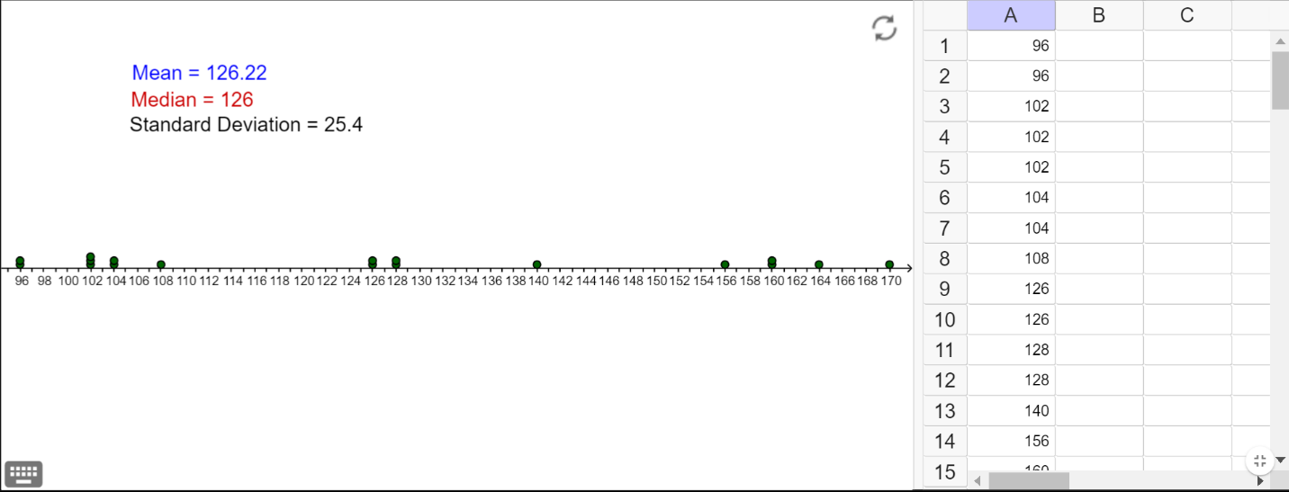

**6-34.**

Mean: 

Median: 

Mode: 92.2, 92.7, 88.3, 90.4, 91.0, 90.1, 86.7, 91.1

* Mean describes the average value in the set of data
* Median describes the number that is at the middle location in the set of data
* Mode describes numbers which occurs most in the set of data

**6-54.**

The female students ‘ heights:

62 64 61 67 65 68 61 65 60 65 64 63 59 68 64 66 68 69 65

67 62 66 68 67 66 65 69 65 69 65 67 67 65 63 64 67 65

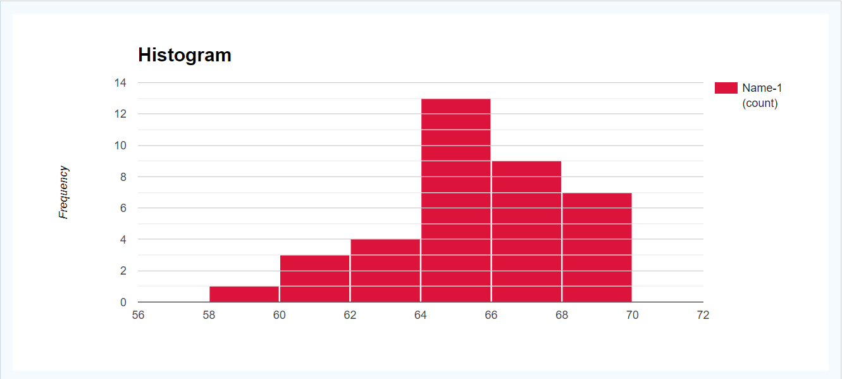

**6-74.**

The motor fuel octane ratings of several blends of gasoline: data in exercise 6-30

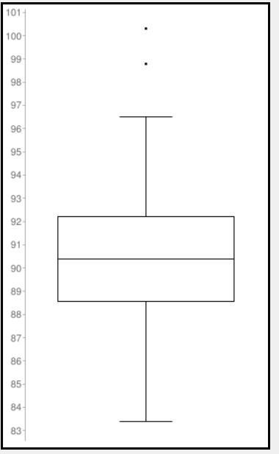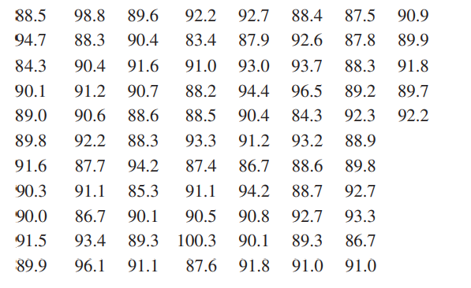

Population size N = 82

Median q2 = 90.4

First quartile q1 = 88.575

Third quartile q3 = 92.2

Interquartile Range IQR: = 3.625

Outliers: 100.3, 98.8

The box plot can show the visual variability and the location where data gathers most. The stem and leaf diagram can show the details of data, the range which has most data but not a clear view of varibility.

**6-82.**

Stem and leaf plot:

|  |  |
| --- | --- |
| Stem | Leaf |
| 42 | 9 8 |
| 43 | 2 0 5 1 0 6 3 0 1 2 6 2 5 0 |
| 44 |  |
| 45 |  |
| 46 |  |
| 47 | 9 9 2 5 9 |
| 48 | 6 0 4 1 0 6 8 1 3 9 6 0 6 0 3 5 1 0 3 |

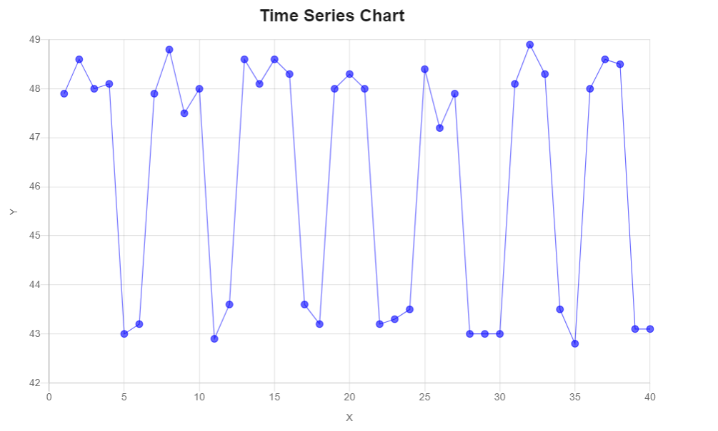 Time series plot:

Remark: The viscosity happens 3 or 4 hours continuously between each 2 or 3 hours.

* Therefore, the process performance was not good at all.

**7-6.**

Population: , 

* Sample with size n = 6: 
* Sample with size n = 49: 



=> When the sample size is increased from n = 6 to n = 49, the standard deviation will decrease 2.9 times.